OUTPUTS

1. DATABASE SCHEMA:

Patients:

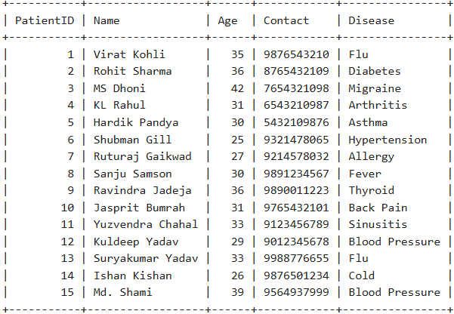

Doctors:

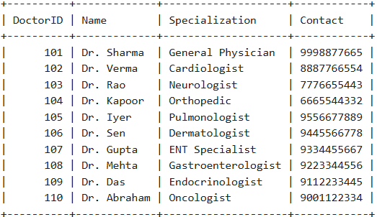

Appointments:

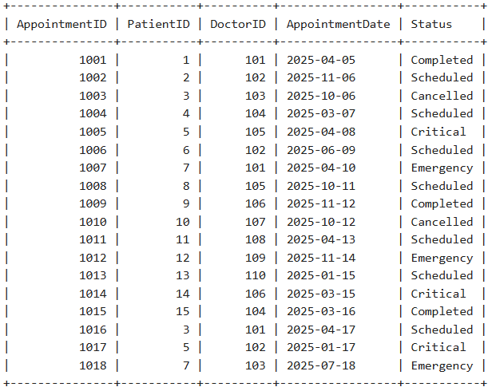

1. AFTER REMOVING REDUNDANT DATA:

Patients:

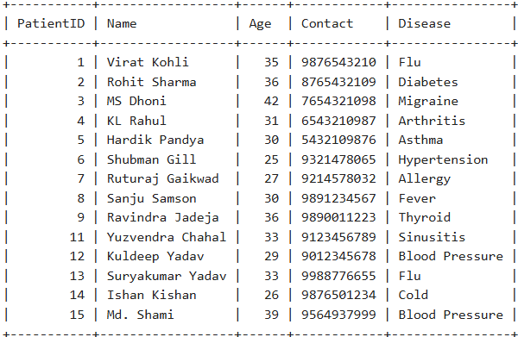

Appointments:

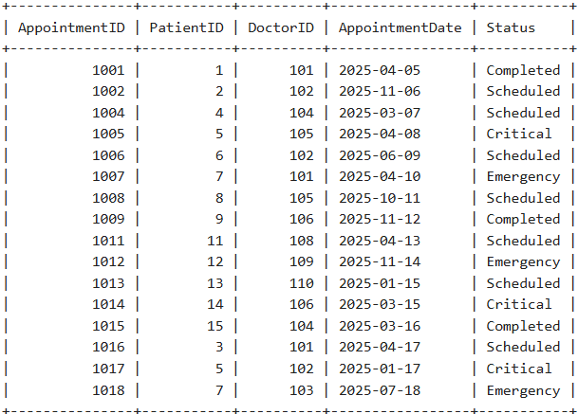

Get appointments by doctor name:

CALL GetAppointmentsByDoctor('Dr. Iyer');

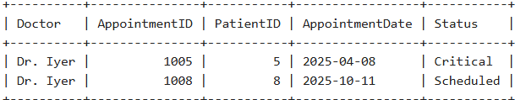

Find patients who have visited multiple times:

CALL GetFrequentPatients();

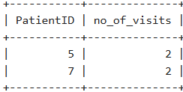

Update appointment status after completion.

CALL UpdateAppointmentStatus(1002, 'Completed');



Get a list of doctors with the most appointments.

CALL GetDoctorsWithMaxAppointments();

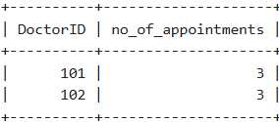

Identify patients with critical conditions.

CALL GetCriticalPatients();

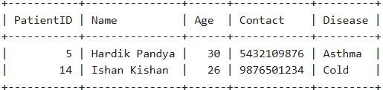

Retrieve appointments scheduled for the next week.

CALL GetNextWeekAppointments(); #Current Date: 2025-04-06

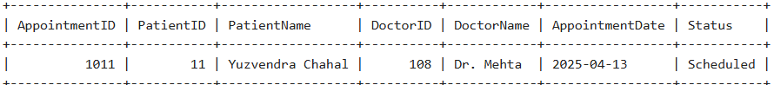

Delete old patient records after five years.

CALL DeleteOldPatients();

Example:(Not the original Schema, only to demonstrate **this** procedure)

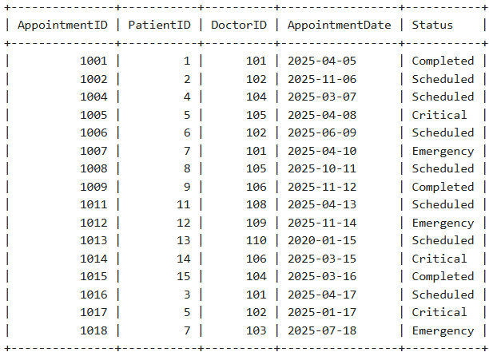 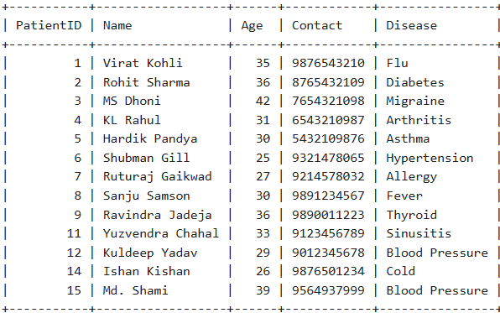

Note: Patient with PatientID=15 Has Been Dropped(Right)

Calculate the total number of patients treated in a month.

CALL GetMonthlyAppointments(4); # April

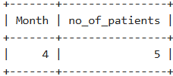

Find doctors available for emergency cases.

CALL GetEmergencyDoctors();

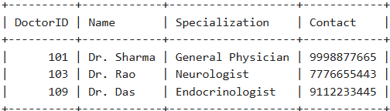

Retrieve patients with the same disease.

CALL GetPatientsGroupedByDisease();

